Life Changing Decision
Name
Instructor`s Name
Name of College
Date

Transformation from Despondence to Hero
I sat pensively in the boardroom, on the chair facing directly the chairman`s, with confusion and dejection plastered all over my face. I was thinking about nothing in particular, but my mind was racing up down a myriad of actions and decisions that would make one be given an award if they said they were absurd and senseless as they were driven and guided by desperation. There is little doubt that desperation clouds judgment.
So what was lingering on mind would have for sure set up a meeting with me and the jury. The letter lay before me, turned upside down for I did not want to see the contents anymore, not after going through it countless times hoping that each time would change the meaning to something that I wanted to hear. But each go-through only make the message succinct that my services were no longer required, until after such time that the board would decide that they were. That was standard procedure of sending you away, ostensibly, with soothing pain.
Events preceding this were eclipsed with speed and lack of clarity by the manager. Perhaps it was my prejudgment and the dire need to make an impression of dedication and initiative. It led to the declaration of the usurpation of authority and my commission of signing checks and thereby sanctioning and giving the green light to payment of deals that had for quite some time been suspected, with sufficient amount of facts, as fraudulent. I was therefore palpably culpable of this undoing, but a reprimand was obviously not enough.
The clock kept ticking, louder than before this time, reminding me that time was not there seated with me, and waiting to cuddle me with some silly decisions. I don't remember how long I stayed there, but it was long enough to witness what happened next. In the middle of my meditations, I was brought back to life and attention by a series of commotions that filled the room. I was not quite sure what was going on, but judging from these events, something somewhere had gone awry. People were taking off from their duty posts and finding their way out. I noticed that they were making it so hastily that they had no time to pick anything valuable, or invaluable for that matter, either personal or company. All that superseded all else was personal safety. Occasionally there would be a stampede with others falling and make, or otherwise morphing into, bumpy human carpets for other`s escape.
It soon came to my realization that the building was on fire. I did not care if my realization or understanding was the building in entirety or our company alone, predominantly the upper floor that housed the Managing Director`s office as well. Smoke started billowing, albeit lightly, meaning it had not spread wider and had not started long ago. What puzzled me was that the alarm system did not notice this event, and was silent. The water response system was, too, dysfunctional or at least unresponsive so to say.
I cast my look into the room far left and across the boardroom to see if my seagull manager had too bolted for safety. The hatred and anger had made me arrive at the conclusion that he was the type, even if it could be true that I was in the wrong. I did not see him, but I saw his coat still hanged cleanly and neatly on the coat hanger. There was obviously no attempt or struggle to pick it and run out. The fire had started becoming fierce, eating anything paper ruthlessly first and fast. I was seemingly the only one in the room now. I had the option to bolt too but decided not to. I elbowed my way through the falling door frames and cabinets and onto the door of the manager. I saw him lying on the floor, gasping and choking. But I could get to him. His door opened electrically, but the system had apparently been compromised, but the program of the door had no fall back to manual operation. I stood there motionless, wondering and figuring what to do. The fire continued raging and razing anything consumable.
I was the only person between life and death of Mr. Donaldson. Graphics and images of the day`s events kept flashing through and across my mind, and one of them almost took control. This was time for vengeance. He had terminated my services and so did not care how I would handle life without a job, but with a family to take care of. He must pay for his brute, and this was for sure the time. While this was struggling to take center stage, another thought came from the figure-ground. It was needless, and in fact sin and criminal, if I watched and left someone died when I was an option to help. I also remembered that the internet and information system had been on shout down for renovations and upgraded with no backup. As a result of this, everything was saved on the hard drive, in an inner room of Mr. Donaldson.
So this was about salvaging company files and information pertinent to its operations as it was about saving a life. I went for the fire extinguisher nearby, but it was not the type of this type of fire. I contemplated running across to the area near the stairway for the fire hose reel, but that was obviously a bad choice too. There was no way on earth I was going to put out the fire of that magnitude at then single-handedly. So I went for the fire ax next to the extinguisher, broke the glass and got to work. I struck with all might the glass section of the door. In spite of the fact that oxygen had started running out, I was relentless, with every strike producing more force and impact, finally giving me the way to him. I quickly wet his coat, loosened his tie and wrapped the coat around him. I then went straight to the system server room, unplugged the hard drives and came out. With his hand around my neck, we struggled through the now dense smoke, enduring the heat and finally got out. Everybody was amazed at my actions. As the paramedics prepared him for attention, I received a call from the director arranging for a meeting with him.

Appendix
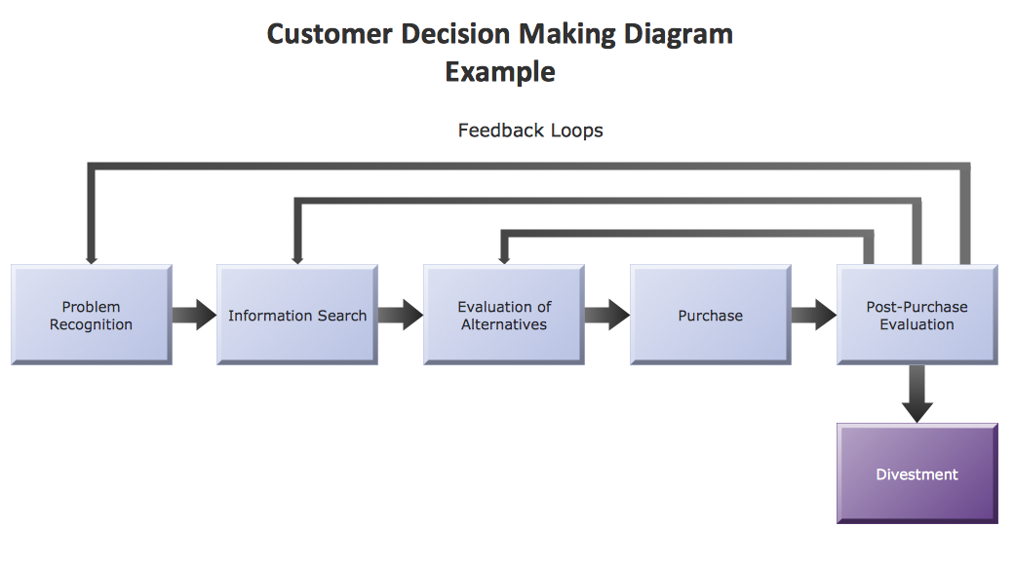
Figure 1 Concept draw samples.
Figure 1 Concept draw samples.
Although the flow is designed for the context of customer interactions, it is well suitable in this case. The problem was the cause of the evacuation of people from the building. Information search was on the cause, and the places of equipment to contain the problem. Alternatives included bolting out too, and leaving the manger to die in the inferno for his actions against me. Additionally, the choice of the appropriate tools was too an evaluation. The purchase section is akin to the action. The next part is like the evaluation of the effects and impacts of the decision taken.

